Automated Web-Based Relative Elevation Model Generator
Frequently Asked Questions

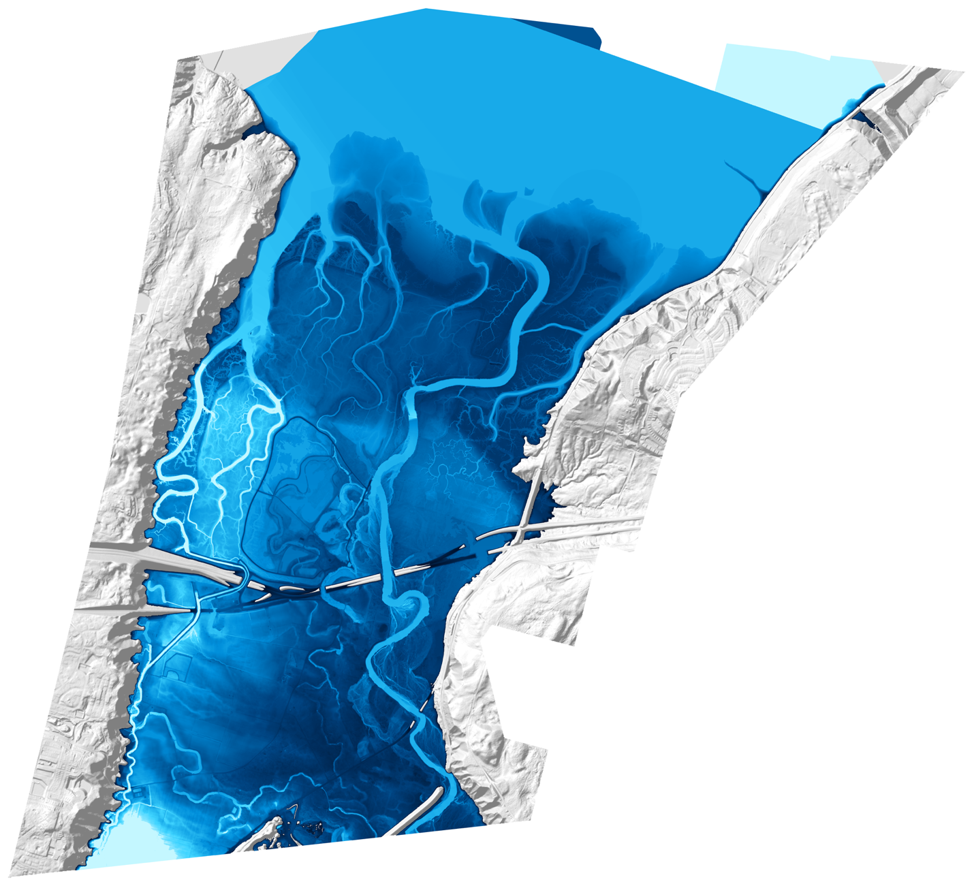
Figure 1: Nisqually River Delta Relative Elevation Model created from a 1 meter resolution Digital Elevation Model and National Hydrography Dataset river centerlines.
Version 1.0
Kleinschmidt Associates
Ethan Muhlestein

1.0 Quick Start Checklist 3
2.0 Installation & Environment Setup 3
2.1 Why do I need Anaconda or Miniconda? 3
2.2 Which Python version should I use? 3
2.3 Installation Troubleshooting 3
3.0 Running the Software 4
3.1 Web Interface vs. Terminal Interface 4
3.2 Common Startup Errors 4
3.3 Can I close the terminal while the web app is running? 5
4.0 Detailed Troubleshooting: Data & System Errors 5
4.1 Data Retrieval Issues 5
4.2 System & Memory Errors 6
5.0 Output Quality Issues (Visual Artifacts) 7
5.1 Empty or "NoData" REM 7
5.2 "Noisy" or Jagged REMs 7
5.3 False Ridges Parallel to River 7
5.4 Negative Values Far from River 8
6.0 Tuning & Performance Optimization 8
6.1 The Performance Triangle 8
6.2 Optimization Strategies 8
7.0 Archiving & Citing 9
7.1 What files should I keep? 9
7.2 How do I cite this software? 9
8.0 Contact & Support 9

1.0 Quick Start Checklist
Do not skip this section. Before reading the detailed FAQs, verify you have completed these steps in order. If any step fails, consult Section 2.0 below.
- Install Anaconda: Ensure Anaconda or Miniconda is installed on your machine.
- Create Environment: Open your terminal or Anaconda Prompt and run the command:
conda create -n rem_env python=3.13 -y
- Activate Environment:
conda activate rem_env
- Install Dependencies:
  - Automated (Recommended): Run python install_requirements.py.
  - Alternative: Run pip install -r requirements.txt.
- Verify Installation: Run the following command to test imports:
python -c "import geopandas, rasterio, streamlit; print('Ready')"

2.0 Installation & Environment Setup

2.1 Why do I need Anaconda or Miniconda?
Regular Python installations often struggle with geospatial packages like geopandas and rasterio because these packages rely on complex C++ dependencies. Anaconda handles these binary dependencies automatically and efficiently.
- Anaconda: This is the full distribution software (approx. 3GB) which includes 250+ pre-installed packages and a GUI.
- Miniconda: This is a minimal version (approx. 400MB) that includes only Conda and Python. If disk space is an issue, use Miniconda.

2.2 Which Python version should I use?
- Recommended: Python 3.12 or 3.13.
- Minimum: Python 3.11.
- Avoid: Python 3.10 or below due to package conflicts.

2.3 Installation Troubleshooting
Problem: I installed Anaconda but the ‘conda’ command is not found.
- Windows Users: You must use the "Anaconda Prompt" from your Start Menu, not the standard Command Prompt. If you do not see it, reinstall Anaconda and ensure you check the "Add to PATH" option.

- macOS/Linux Users: Type conda info in your terminal to verify the installation path and details.
Problem: Installation says “Solving environment…” and takes a long time. Anaconda’s solver downloads complex binary libraries, which can take 5–20 minutes depending on your internet connection.
- Solution: The best option is to wait and let the environment solve.
- Advanced Fix: You can install mamba (a faster solver) by running conda install mamba -n base -c conda-forge -y and then using mamba install instead of conda install.
Problem: Error "Could not find a version that satisfies the requirement" This usually means a package version specified in the requirements file is not available for your specific Python version.
- Fix: Try installing the package using pip or conda without a specific version number. Alternatively, create a new environment with a different Python version (e.g., 3.12 instead of 3.13).

3.0 Running the Software

3.1 Web Interface vs. Terminal Interface
- Web Interface (Recommended): A browser-based point-and-click interface easiest for most users. Launch it using python run_app.py.
- Terminal Interface (Advanced): A command-line workflow that does not require a web browser. Launch it using python run_rem_guided.py.

3.2 Common Startup Errors
Error: “No such file or directory: ‘app.py’” This error occurs because you are not in the correct directory. You must use the cd command to navigate to the folder where the software lives before running the python command.

Error: Web interface doesn't open in browser. If the browser doesn't launch automatically:
- Look in the terminal for the Local URL (e.g., http://localhost:8501).
- Copy and paste that link into Chrome, Edge, or Firefox.
- Port Conflict: If port 8501 is in use, run the app on a different port by using the command python -m streamlit run_app.py --server.port 8502.
- Kill Process: If Streamlit is stuck in the background, run taskkill /F /IM streamlit.exe (Windows) or pkill -f streamlit (macOS/Linux).
Error: “ModuleNotFoundError: No module named ‘streamlit’” Your environment is likely not activated. Run conda activate (Environment Name) and try again.

3.3 Can I close the terminal while the web app is running?
No. The Anaconda Prompt/Terminal MUST stay open while using the web interface. The terminal runs the web server; if you close it, the server stops. To stop the server manually, press Ctrl+C in the terminal.

4.0 Detailed Troubleshooting: Data & System Errors

4.1 Data Retrieval Issues
"DEM Download Failed / Timeout"
- Causes: This can be caused by internet connection issues, the USGS server being temporarily down, or firewalls blocking the download .
- Solution 1: Wait 15–30 minutes and retry. The software automatically retries 5 times, but server maintenance can last longer.
- Solution 2: Use the Manual Upload feature. Download the DEM manually from USGS Earth Explorer and upload it via the "Custom DEM & River" mode.

"No Rivers Found in AOI"
- Causes: The AOI polygon may be too small, or the area contains only unnamed tributaries not included in the NHD dataset.
- Solution: Draw a larger polygon that clearly includes the river (try a 500m buffer). Alternatively, manually digitize the river centerline in QGIS/ArcGIS and upload it as a Shapefile or GeoPackage .

"CRS Mismatch Error"
- Causes: The DEM and River files use different coordinate reference systems (e.g., EPSG:5070 vs EPSG:4326).

- Solution: The software usually handles this automatically. If it fails, open QGIS or ArcGIS and reproject both files to the same CRS (e.g., EPSG:5070 for CONUS) before uploading.

4.2 System & Memory Errors
“Insufficient RAM” / “Out of Memory” / “Python Stopped Working”
- Causes: High-resolution DEMs (1-meter) over large areas can require massive amounts of RAM (e.g., 12GB+).

- Solution 1 (Immediate): Close all unnecessary applications (Chrome, Word, Adobe) and restart the computer to clear memory.

- Solution 2 (Optimization): Set the "Max REM (m) - Comp" to 5 or 10. This excludes high hillslopes/mountains from the calculation, reducing memory usage by 50-80% .
- Solution 3 (Resolution): Switch to a coarser resolution. A 10m DEM uses roughly 90% less memory than a 1m DEM.
“Insufficient Disk Space”
- Causes: Not enough free space to download the DEM and save outputs. 100km² of 1m DEM data can take up 10-20 GB.

- Solution: Clear your Recycle Bin and Downloads folder. Ensure you have at least 10–20 GB of free space as a buffer.

5.0 Output Quality Issues (Visual Artifacts)

5.1 Empty or "NoData" REM
Symptom: The REM output is entirely NoData (value -999) or empty.
- Cause: The river centerline does not actually overlap the DEM, or the "Max REM" parameter was set too low (e.g., 0.5m).
- Fix: Open the mosaic_clipped.tif and river_reprojected.gpkg in GIS software to visually verify overlap. Rerun the process with the "Max REM" field left blank.

5.2 "Noisy" or Jagged REMs
Symptom: The REM has "bulls-eye" circular patterns or spotty noise.
- Cause: Too few K-Neighbors were used for the interpolation.
- Fix: Increase K-Neighbors from the default (8) to 50–100. This creates a smoother interpolation surface.

5.3 False Ridges Parallel to River
Symptom: The REM shows linear ridges or elevated "stripes" running parallel to the river where none exist in reality.
- Cause: Bridges in the DEM are being interpreted as the river bed, creating false high points in the river profile.
- Fix: Increase the Spacing (m) to a higher number. This helps the software "blend out" the spikes caused by bridges.

5.4 Negative Values Far from River
Symptom: The REM shows values like -10m or -20m in areas far from the river.
- Cause: The river centerline may deviate from the actual channel, or the interpolation is extending too far.
- Fix: Manually digitize a corrected centerline in GIS. Alternatively, use the Max REM Limit (e.g., 10m) to exclude these distant areas from the calculation entirely.

6.0 Tuning & Performance Optimization

6.1 The Performance Triangle
You can optimize for two of these factors, but rarely all three: Speed, Quality, or Coverage.
- High Quality + Large Coverage = Slow: Expect long processing times.
- High Quality + Fast = Small Coverage: Requires cutting the area into smaller chunks.
- Large Coverage + Fast = Lower Quality: Requires coarser resolution.

6.2 Optimization Strategies
Strategy 1: The Two-Pass Approach
- Reconnaissance Pass (Fast): Run your area with 10m or 30m resolution, 20m spacing, and 30 K-neighbors. This takes 5–10 minutes and allows you to check for errors .
- Final Pass (High Quality): Once verified, run with 1m resolution, 5-10m spacing, and 100 K-neighbors. This may take 30–60 minutes but yields publication-quality results .
Strategy 2: Tuning by River Size
- Small Streams (<10m wide): Use 1–3m DEM resolution and 5m spacing to preserve local detail .
- Large Rivers (>50m wide): Use 10m DEM resolution and 15-20m spacing and fewer neighbors (30-50) to speed up processing .

7.0 Archiving & Citing

7.1 What files should I keep?
For long-term storage, you do not need to keep every temp file. Save these three essentials:
- REM.tif: The main output raster for GIS analysis.
- REM_Project_Stats.txt: The metadata file documenting your specific parameters.
- REM_[ColorRamp].png: The visualization image for quick reference.

7.2 How do I cite this software?
When publishing results, please use the following format referencing the software and your specific parameters found in the stats file:
"REMs were generated using the Automated REM Generator (University of Utah PMST Program) with [Insert Resolution] USGS 3DEP DEM data. River elevations were sampled at [Insert Spacing] spacing and smoothed with a [Insert Window Size] window. Inverse distance weighting interpolation used [Insert K-Neighbors] nearest neighbors."

8.0 Contact & Support
If you have read through this FAQ guide and the User Manual but still cannot resolve your issue, please contact the developer for further assistance.
- Developer: Ethan Muhlestein
- Email: Ethan.Muhlestein@Kleinschmditgroup.com

